**Standing Up an Amazon Aurora Database with an Automatically Rotated Password Using AWS Secrets Manager**

**Hands-on Lab**

We will use AWS Secrets Manager to securely create and rotate an administrator password for an Amazon Aurora deployment.

**Objectives**

* Create MySQL-compatible Amazon Aurora Database
* Connect to the Aurora Database and Import Data
* Trigger Credential Rotation
* Test Connection with New Credentials
* Verify MySQL Client Installation

**Architecture**

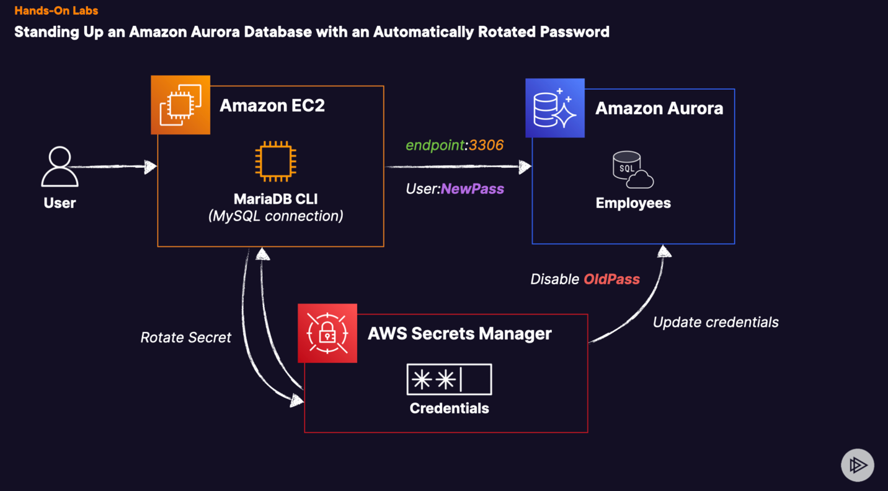

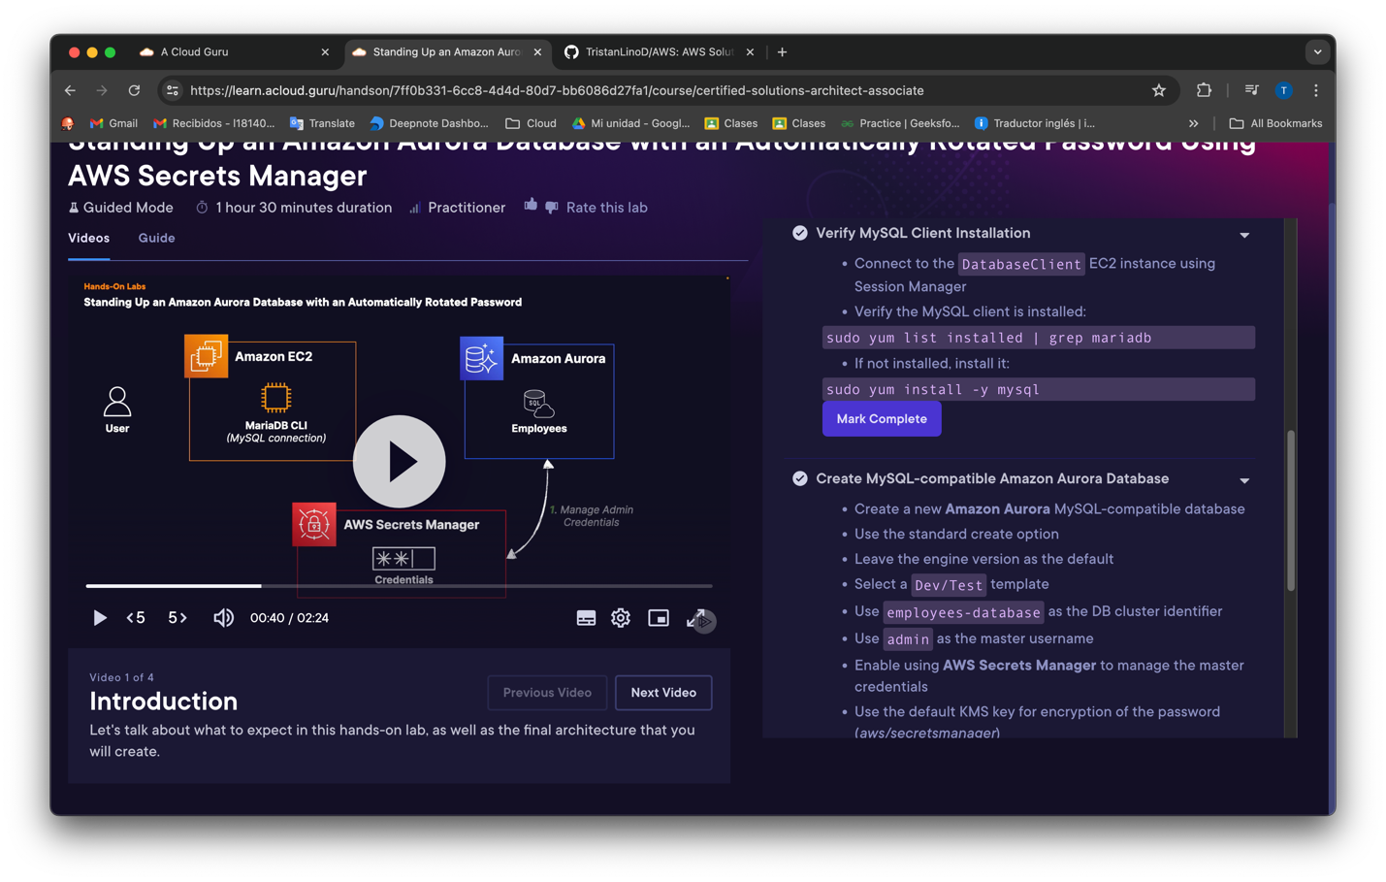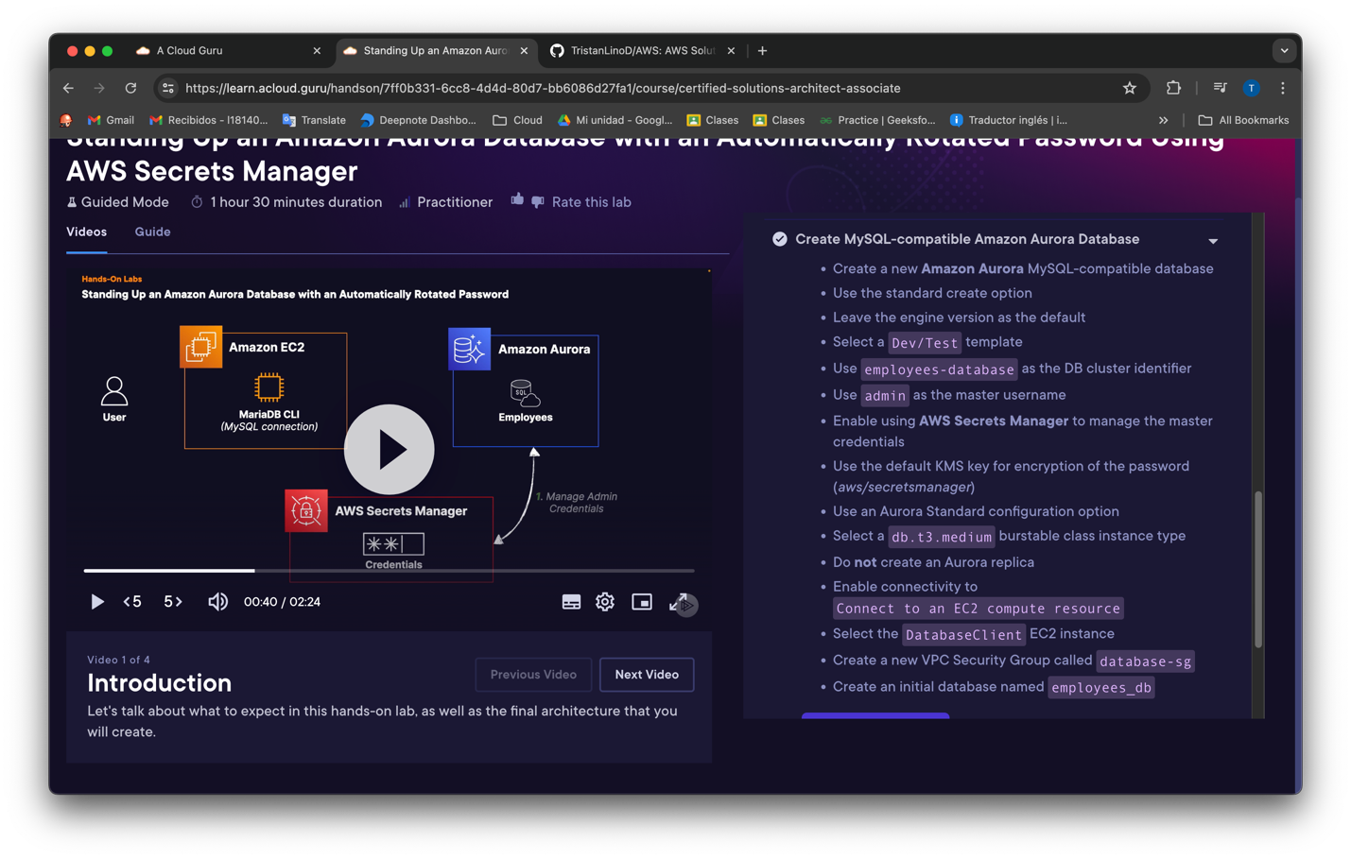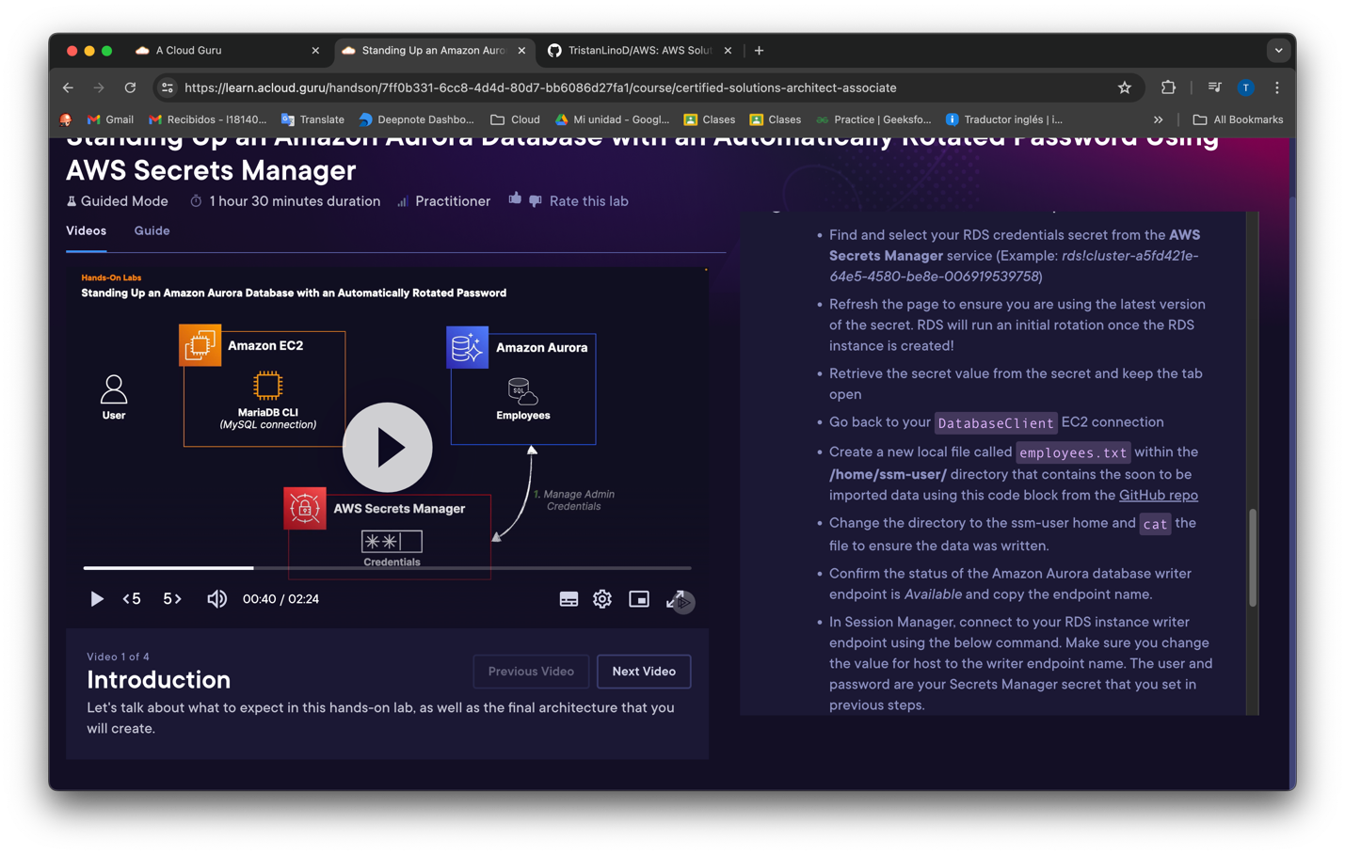

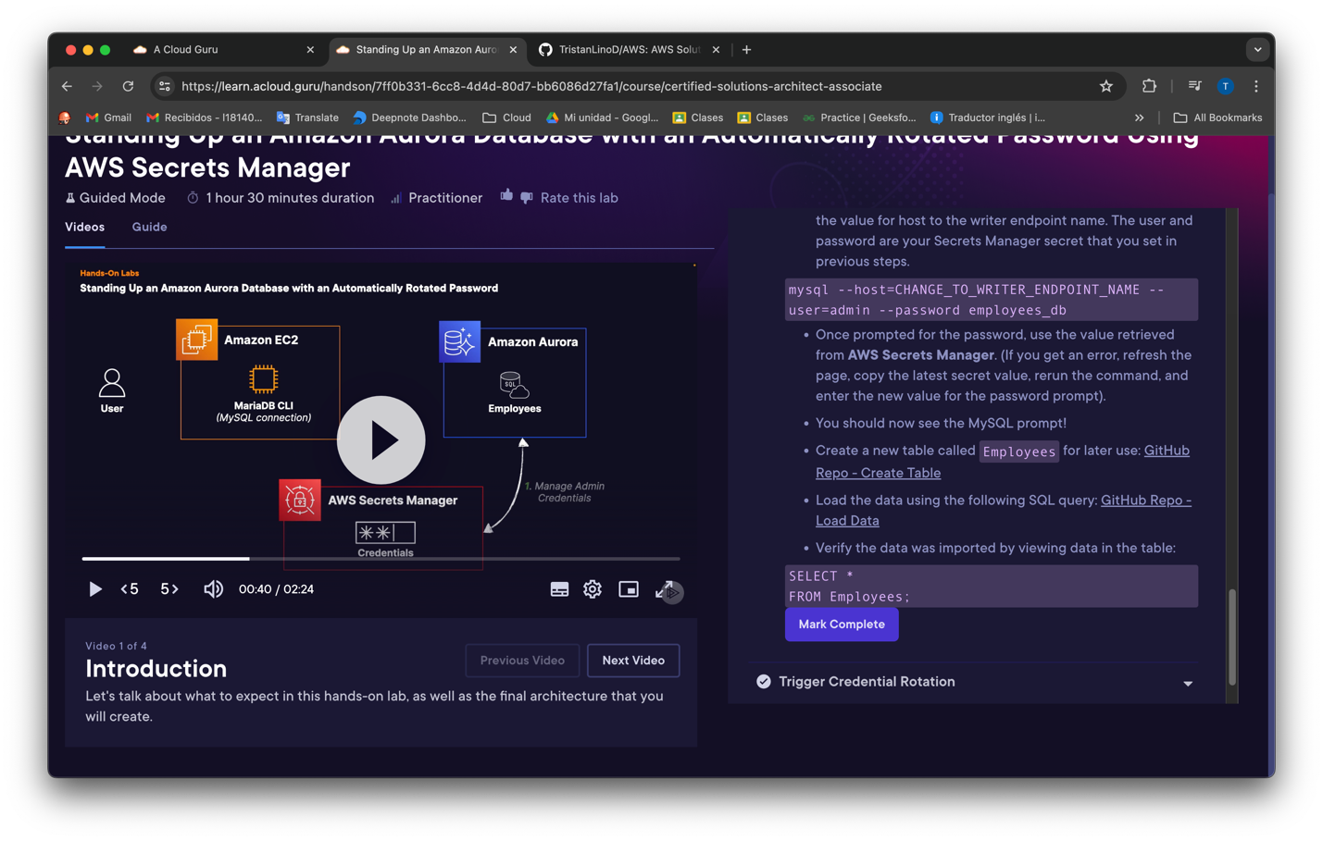

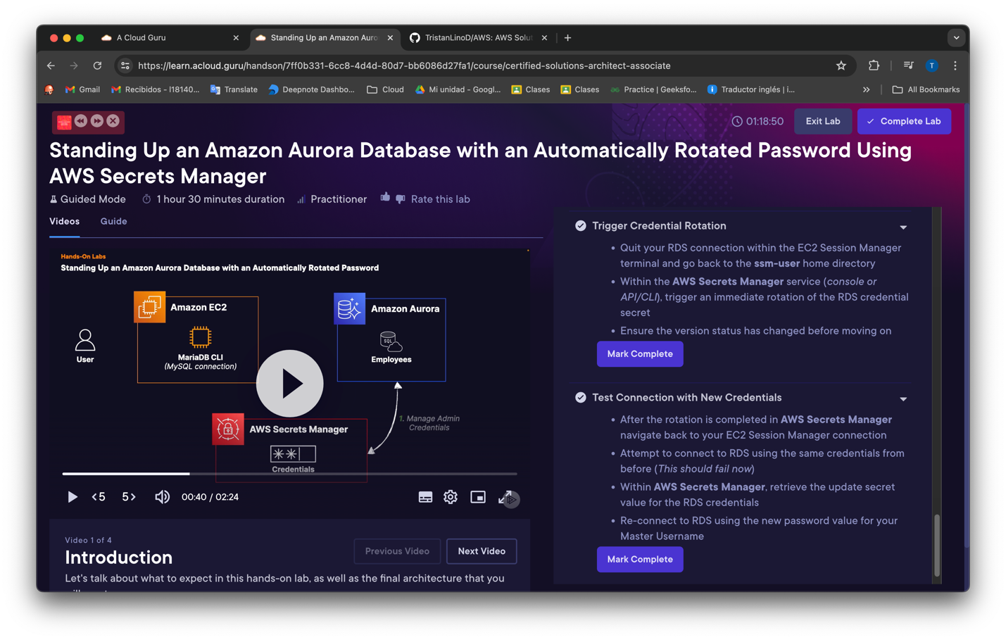

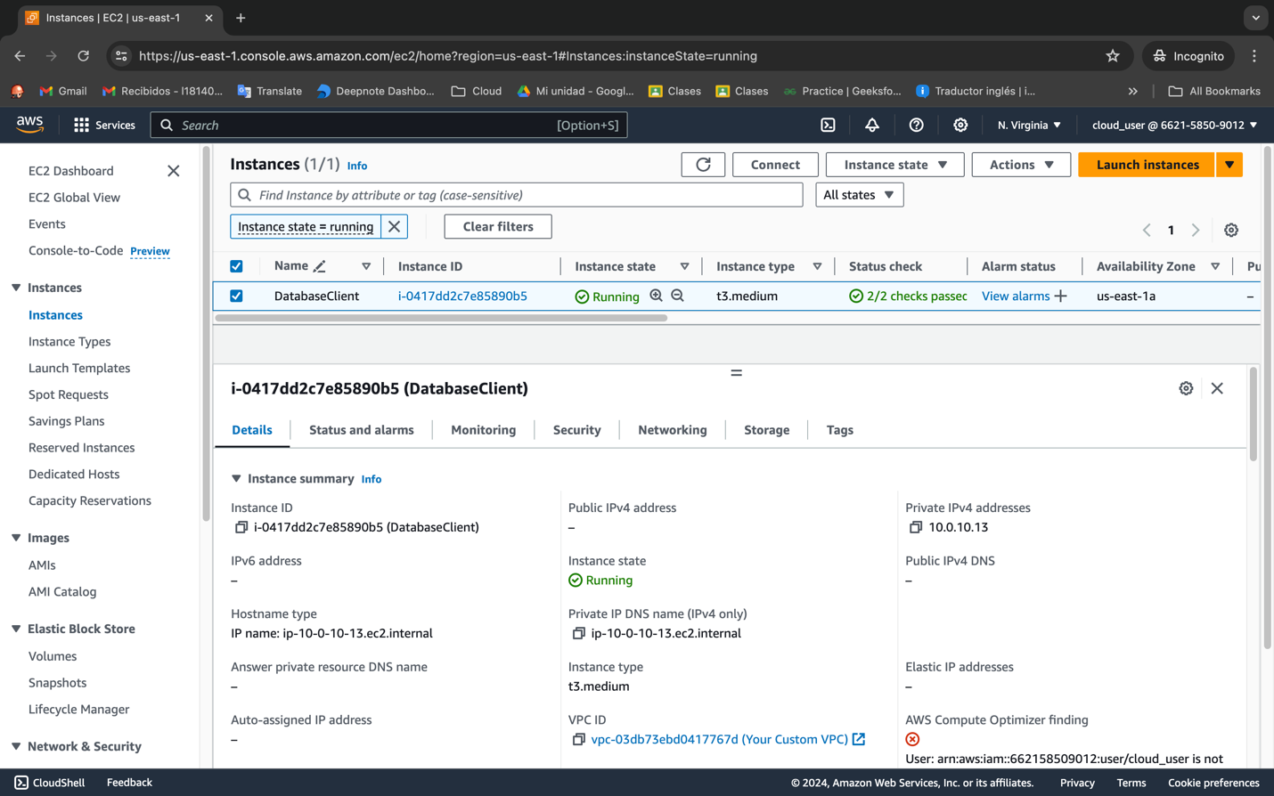

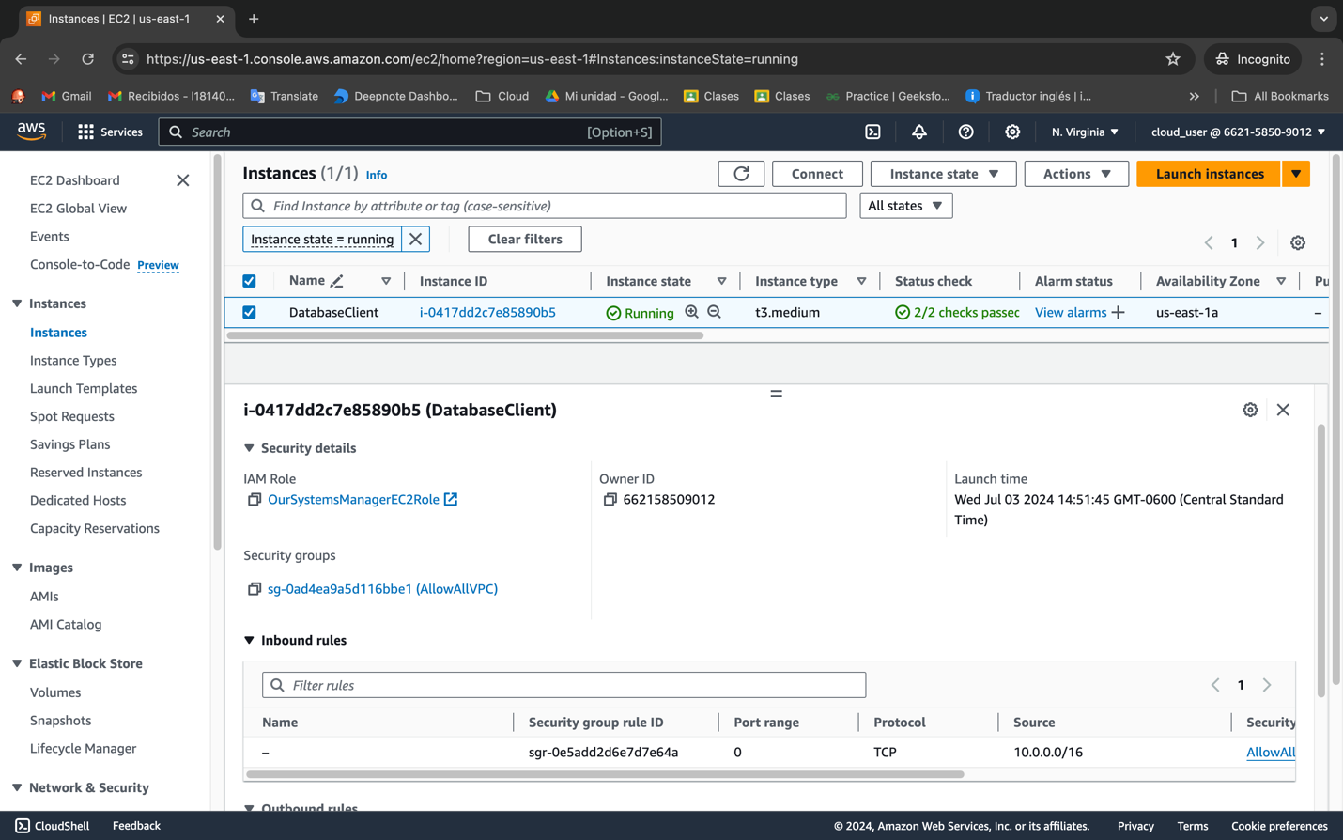

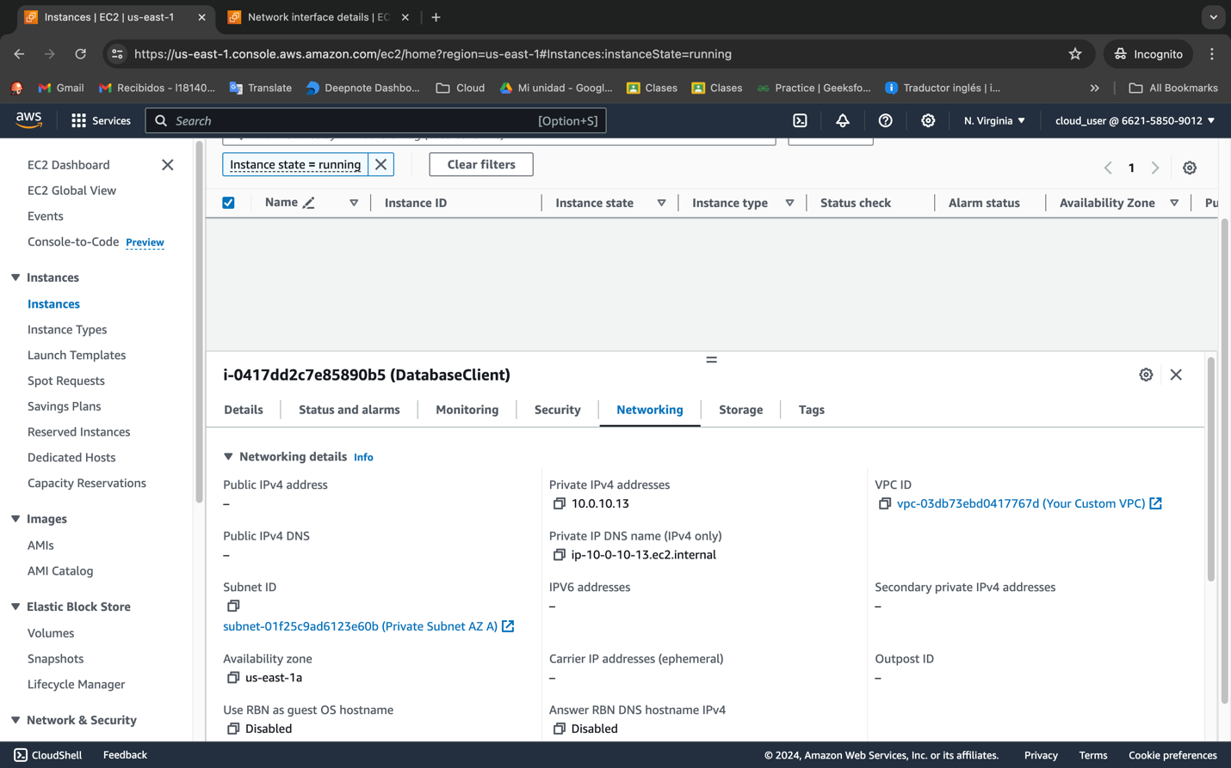

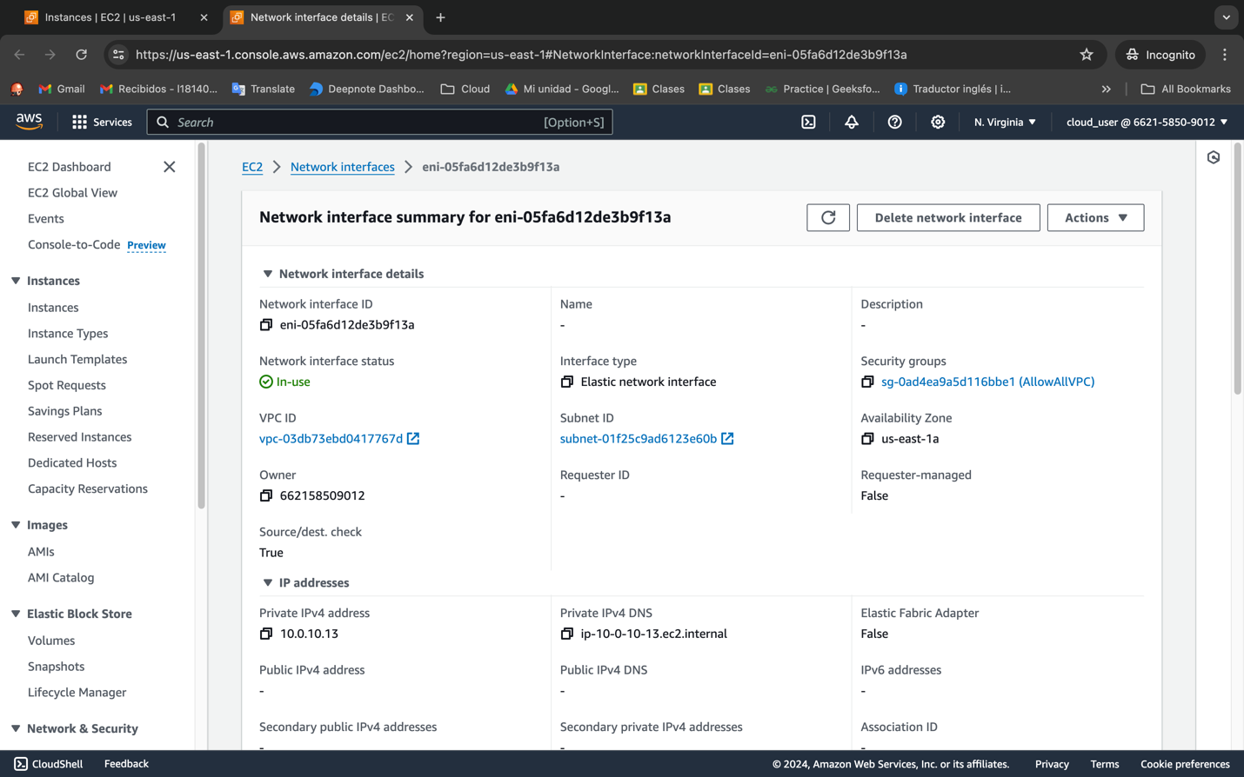

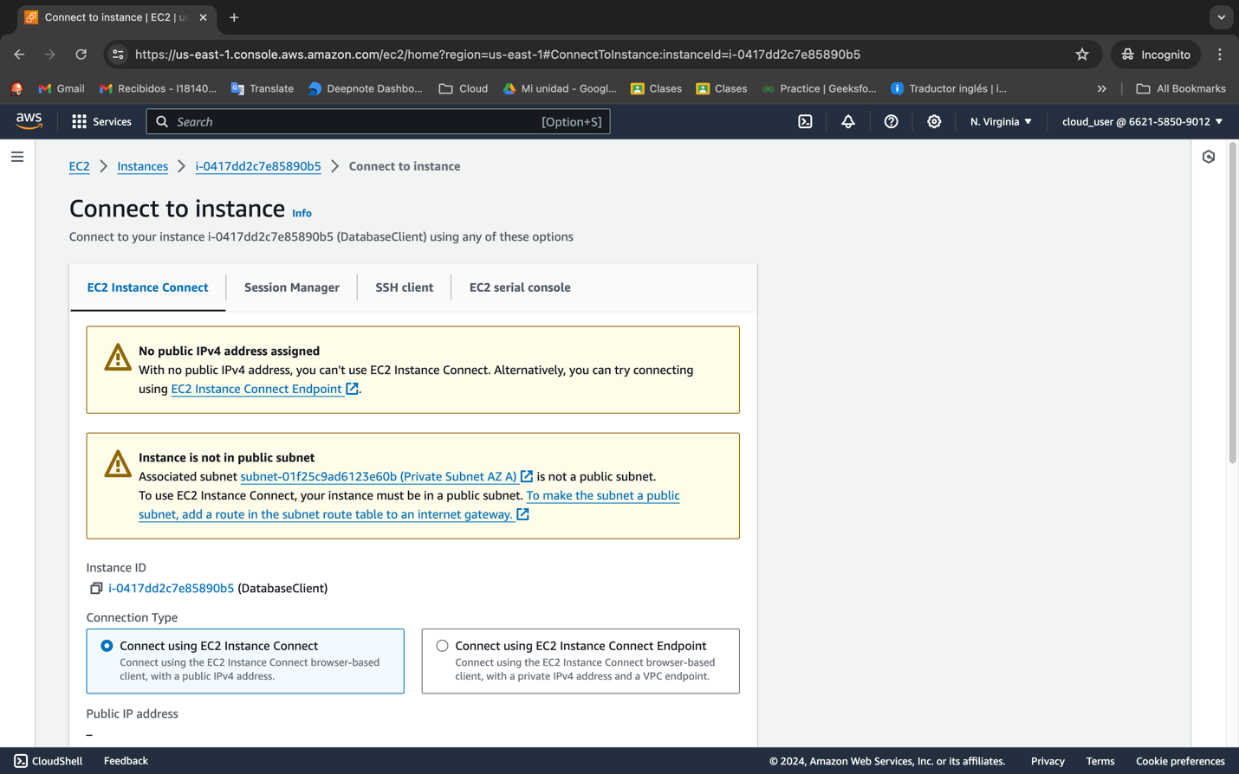

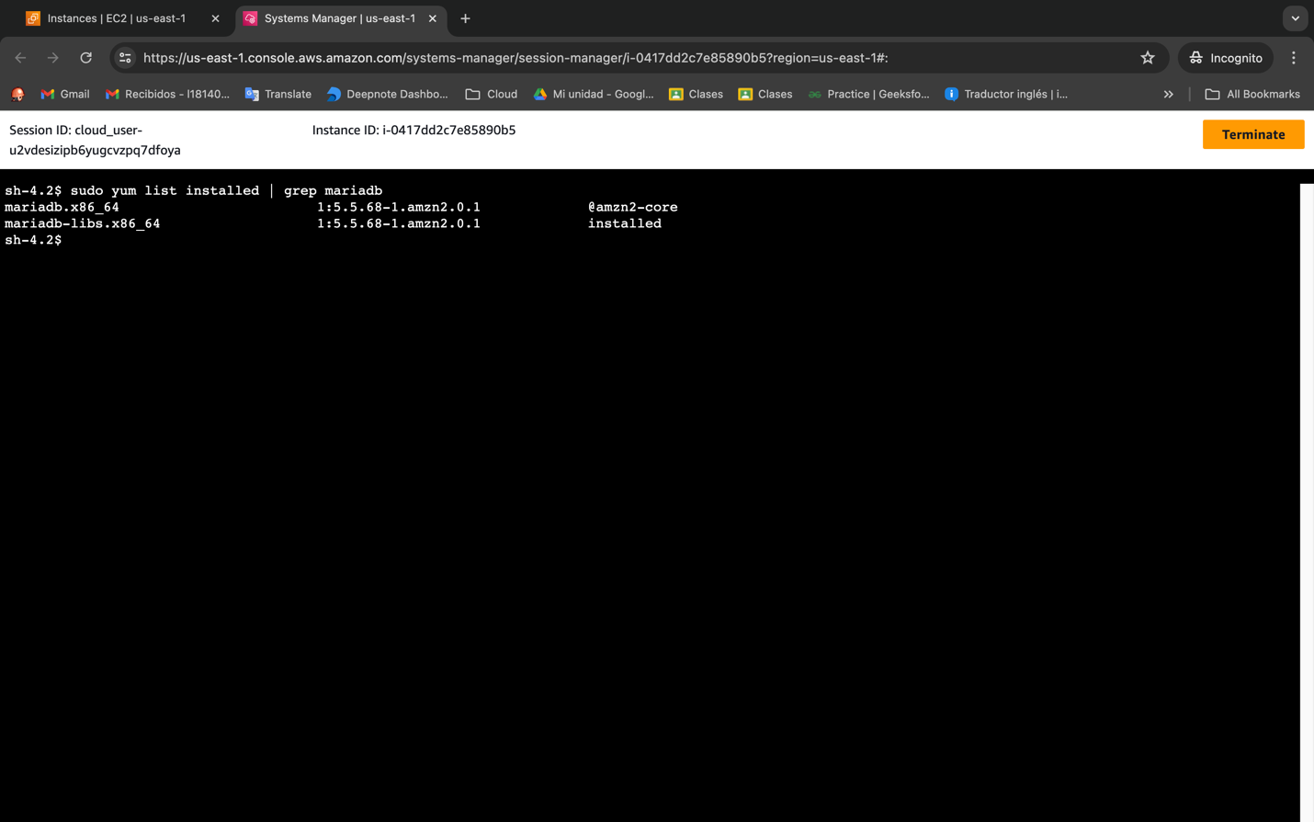

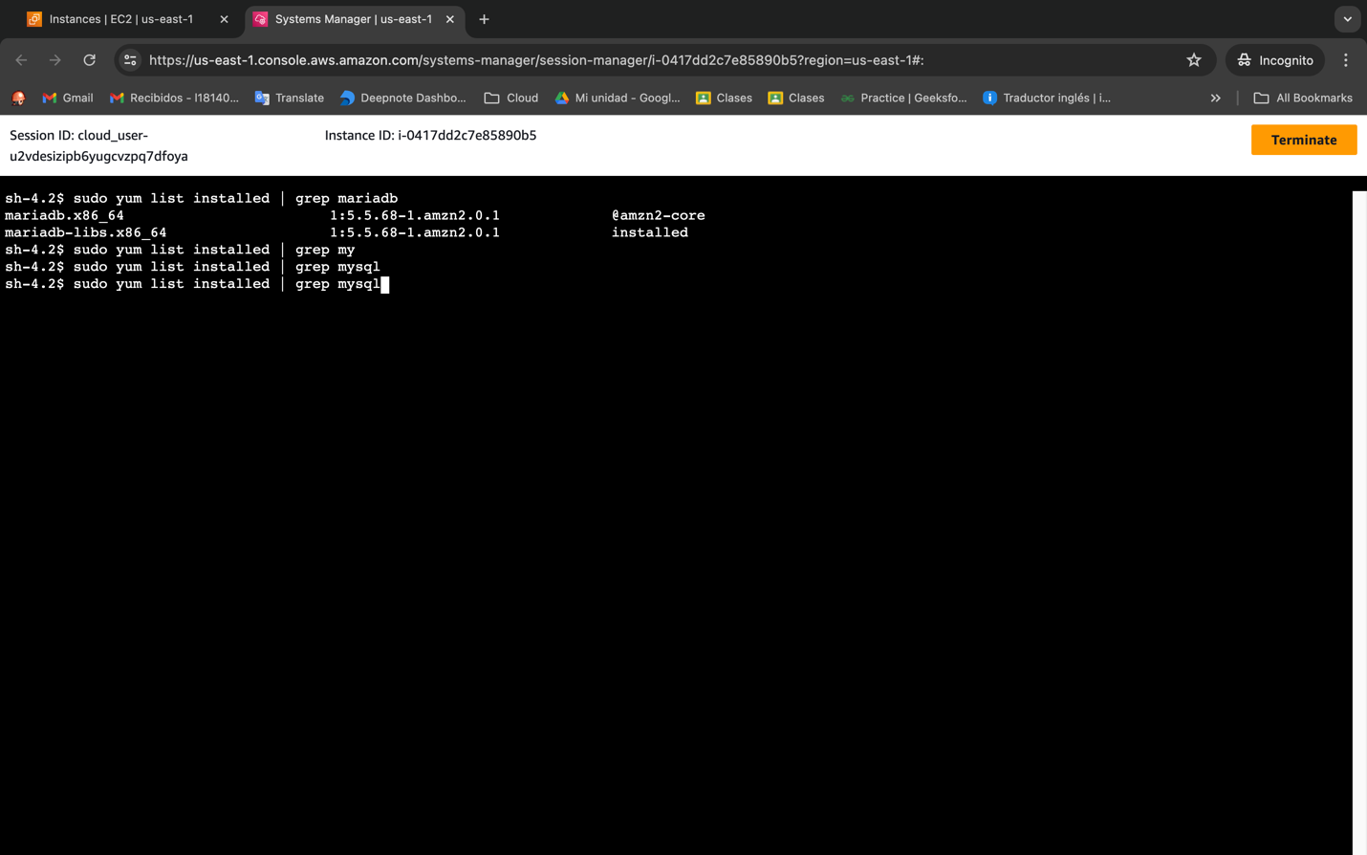

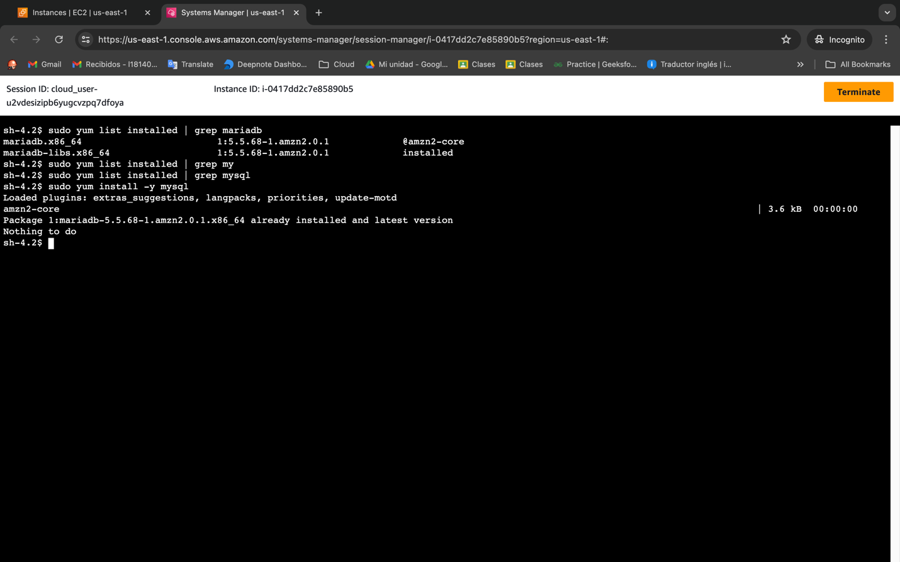

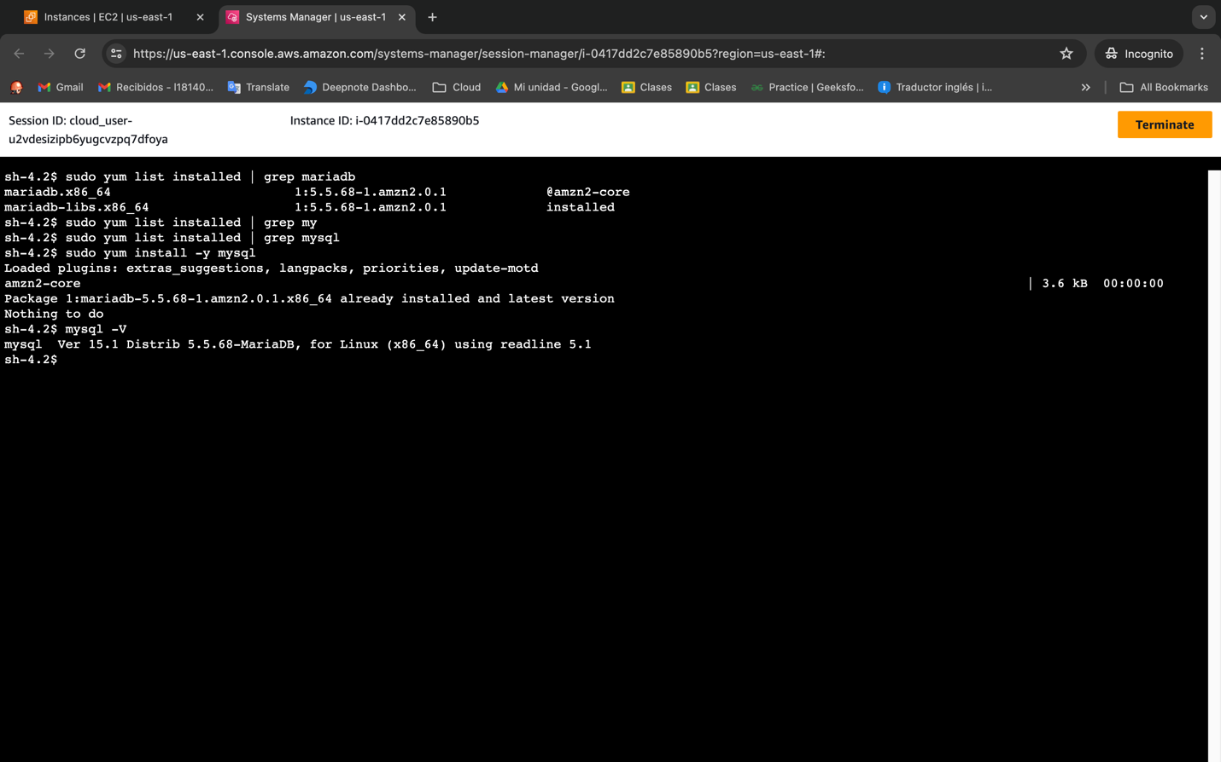

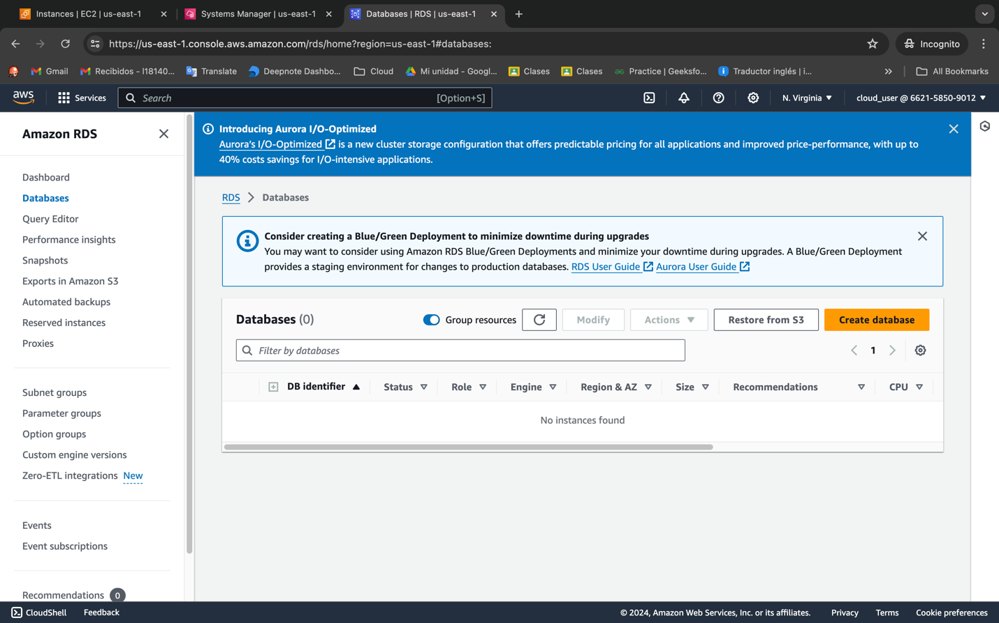

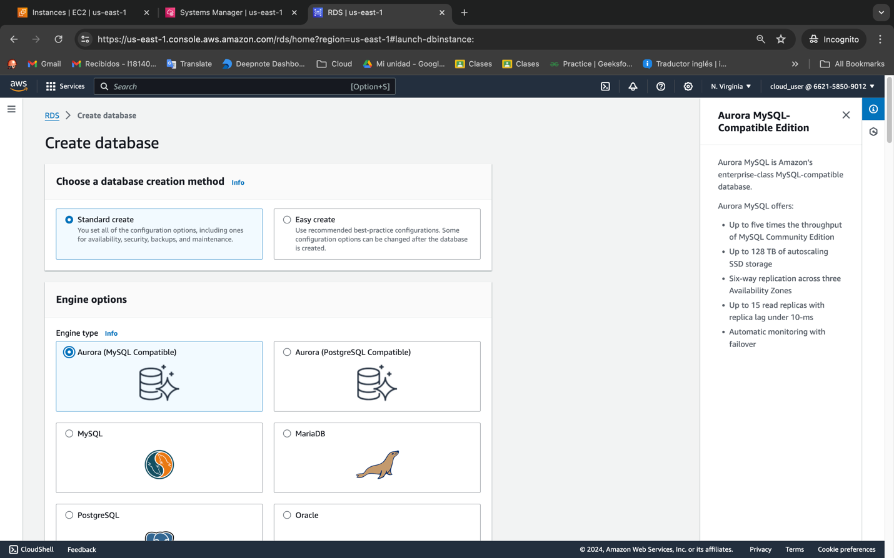

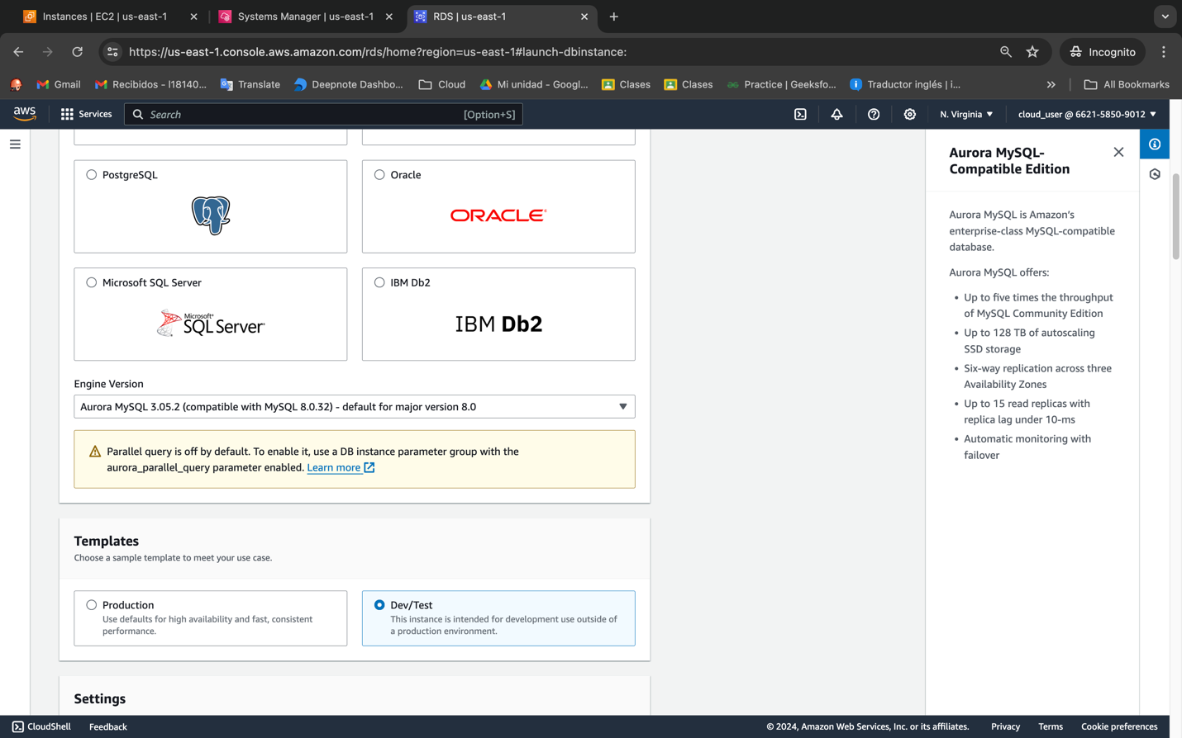

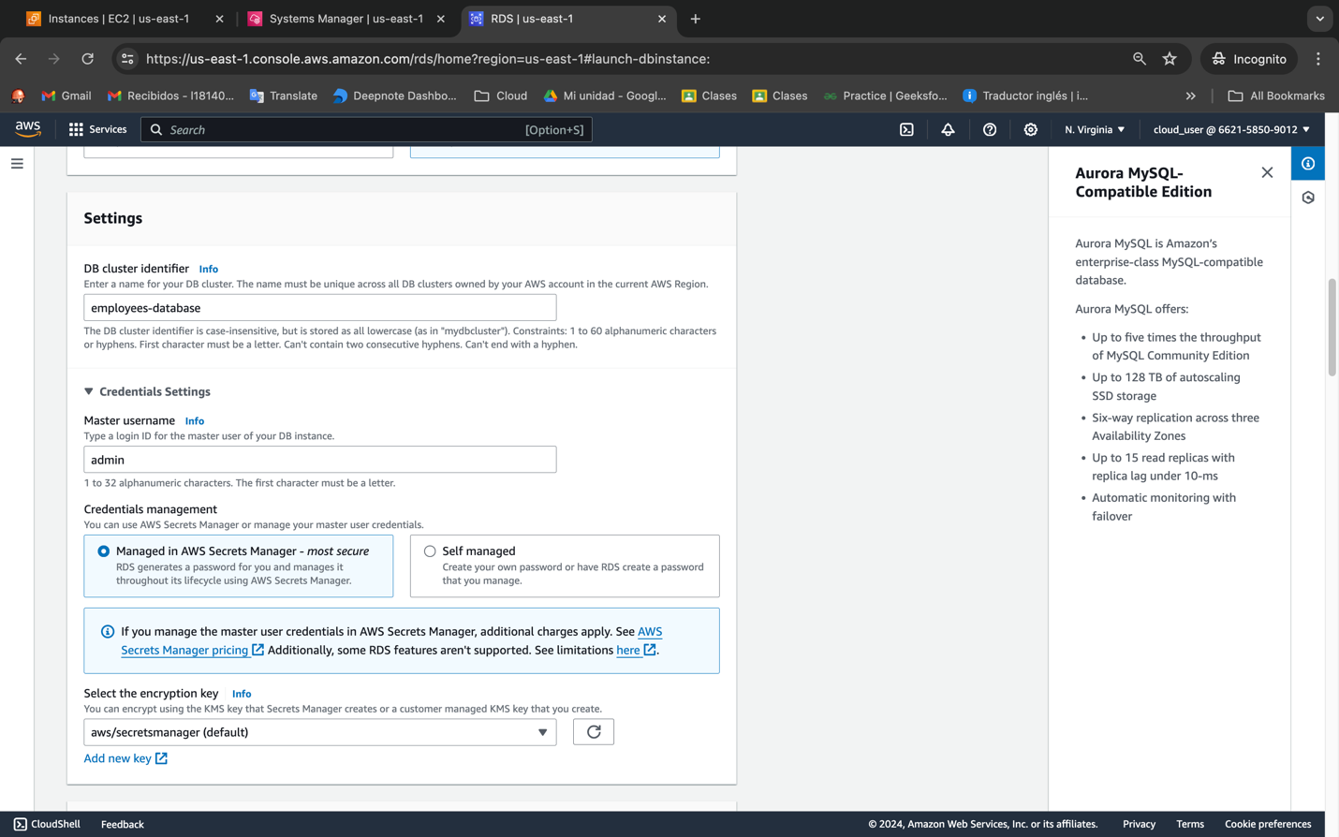

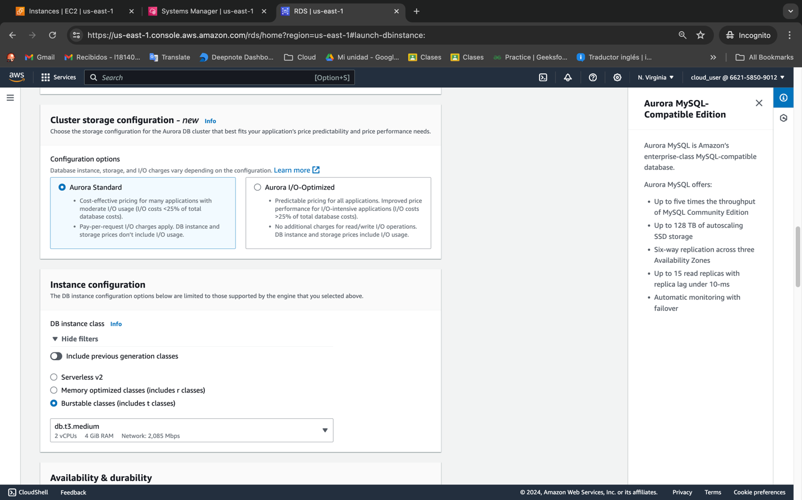

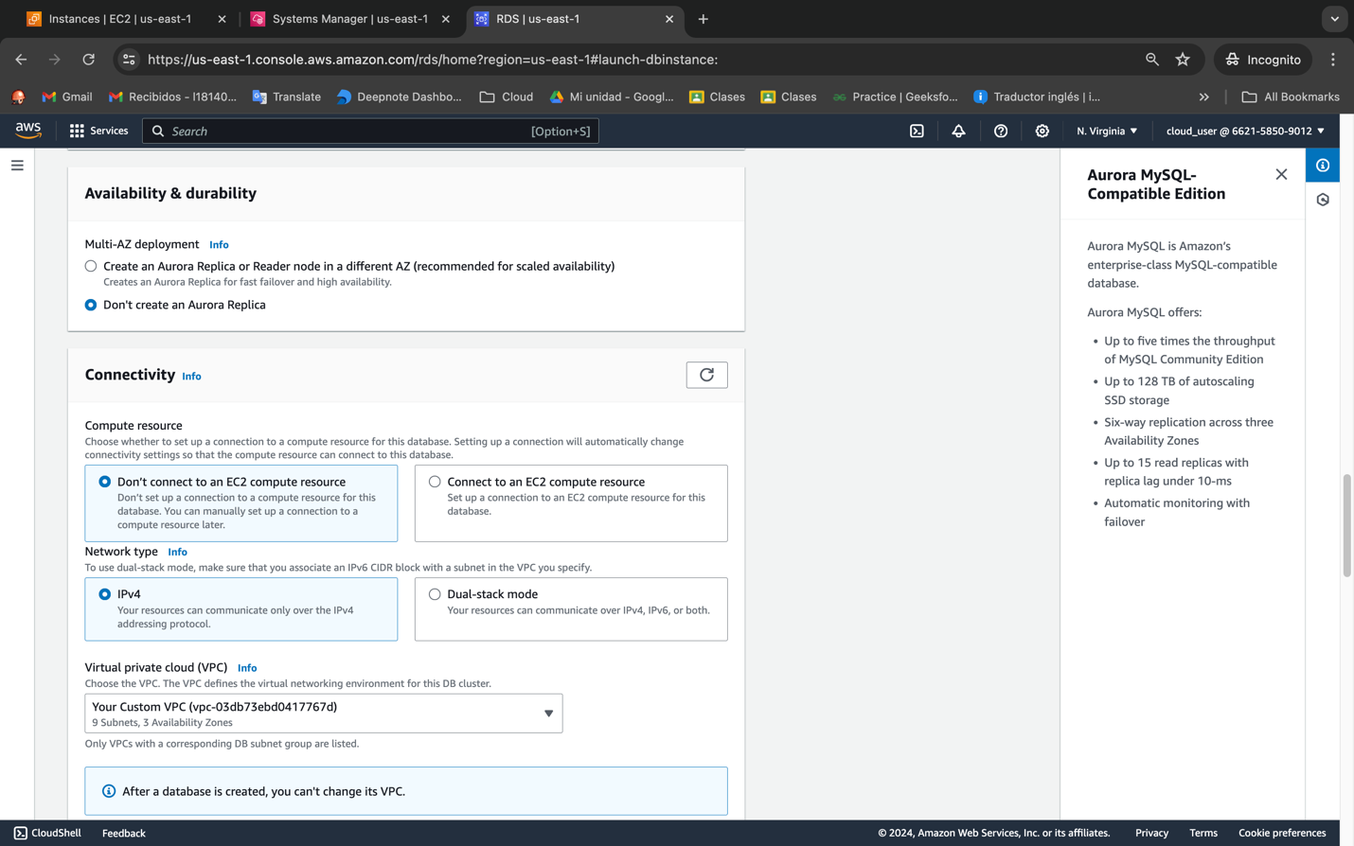

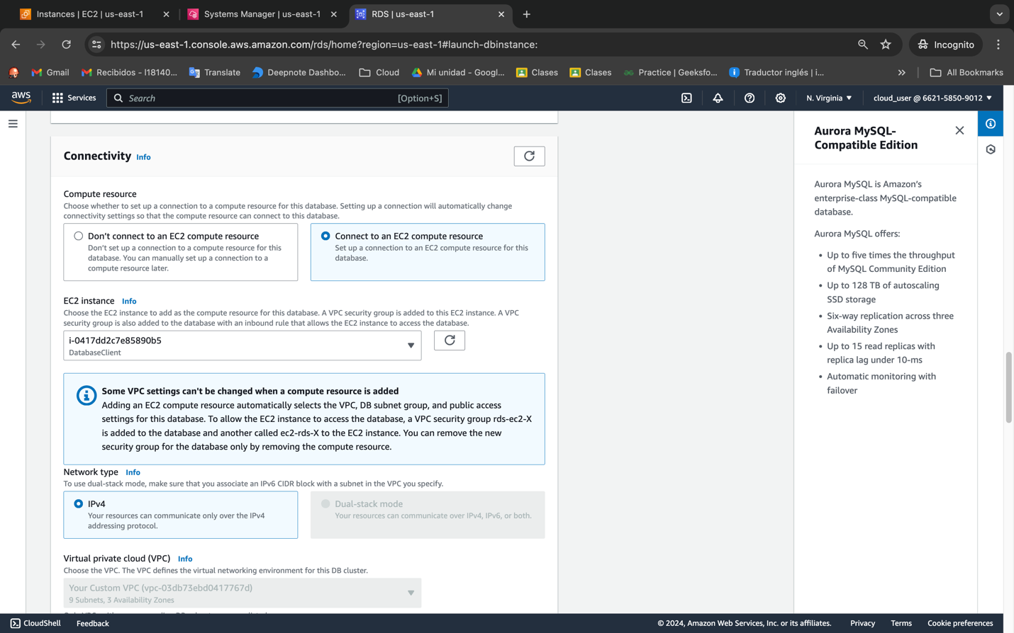

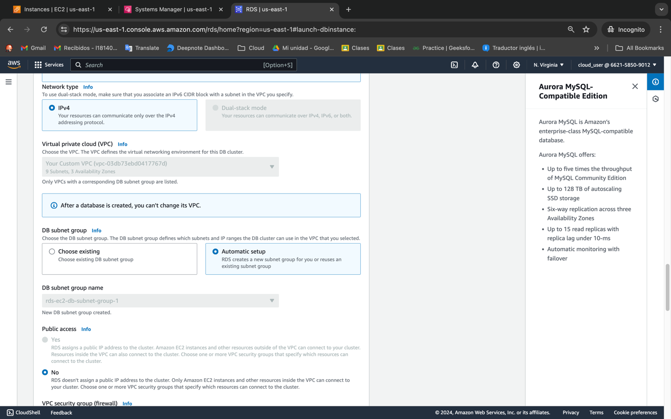

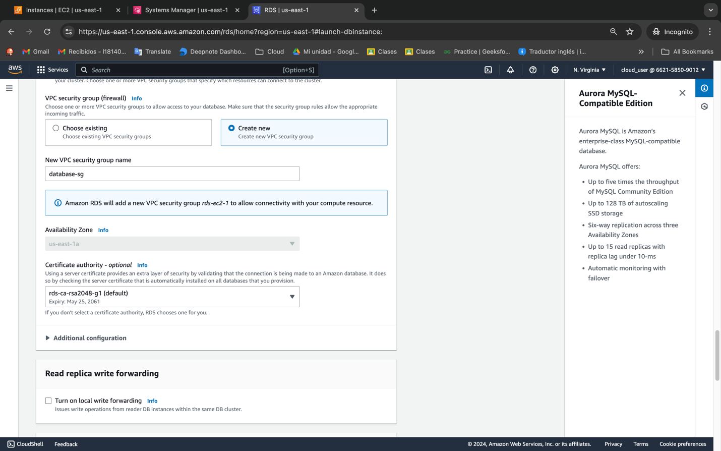

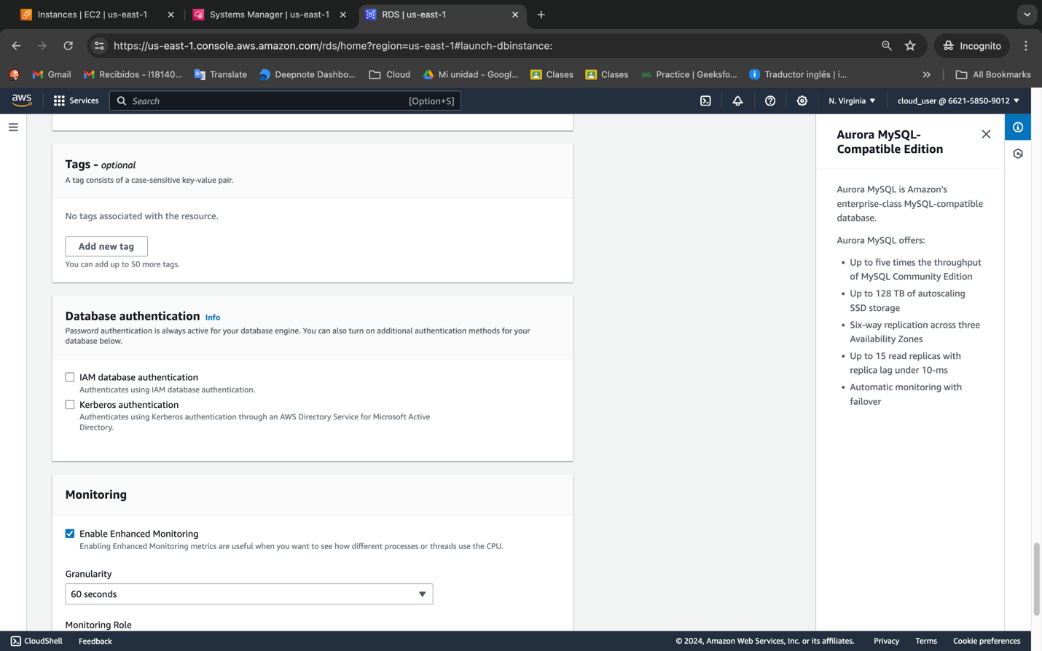

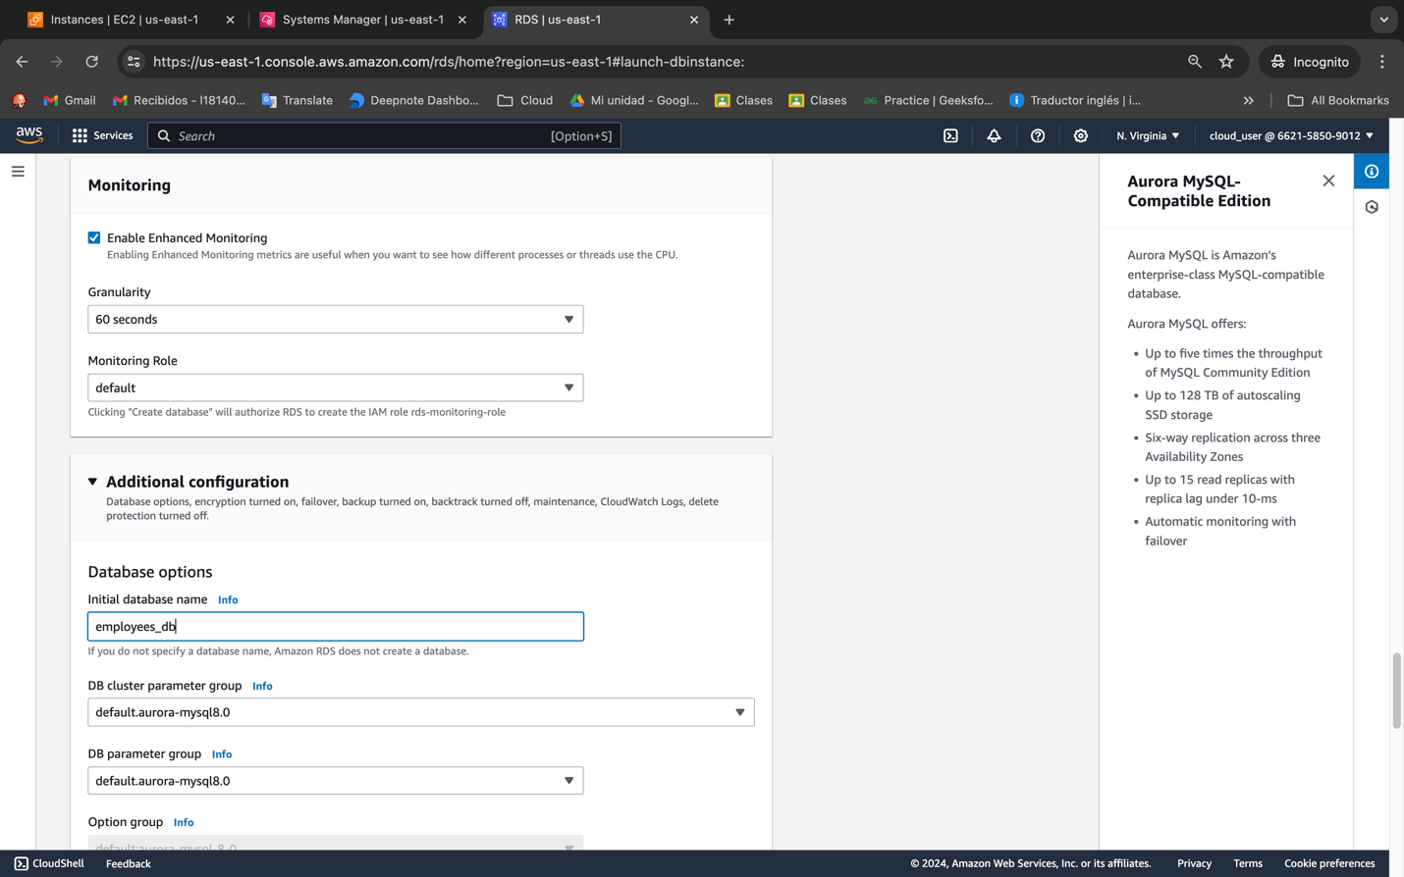

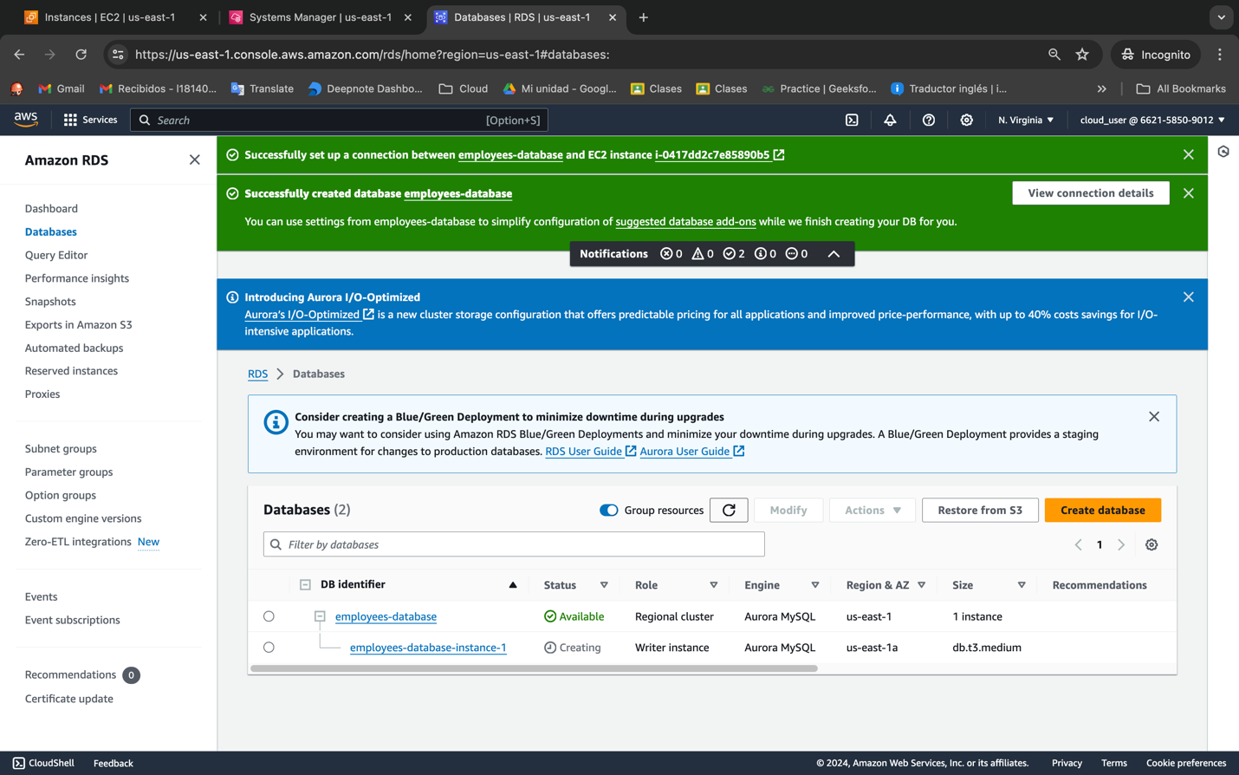

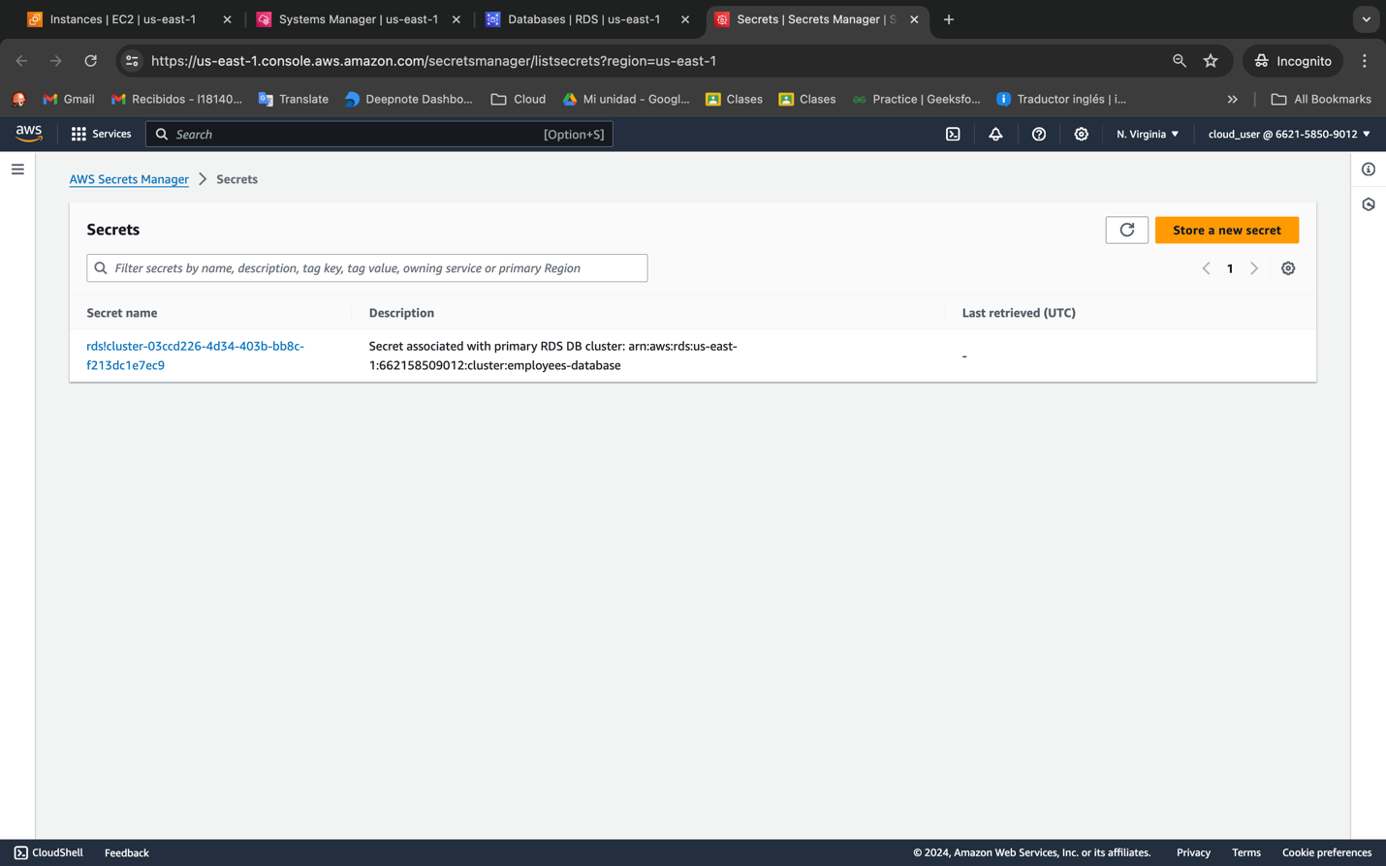

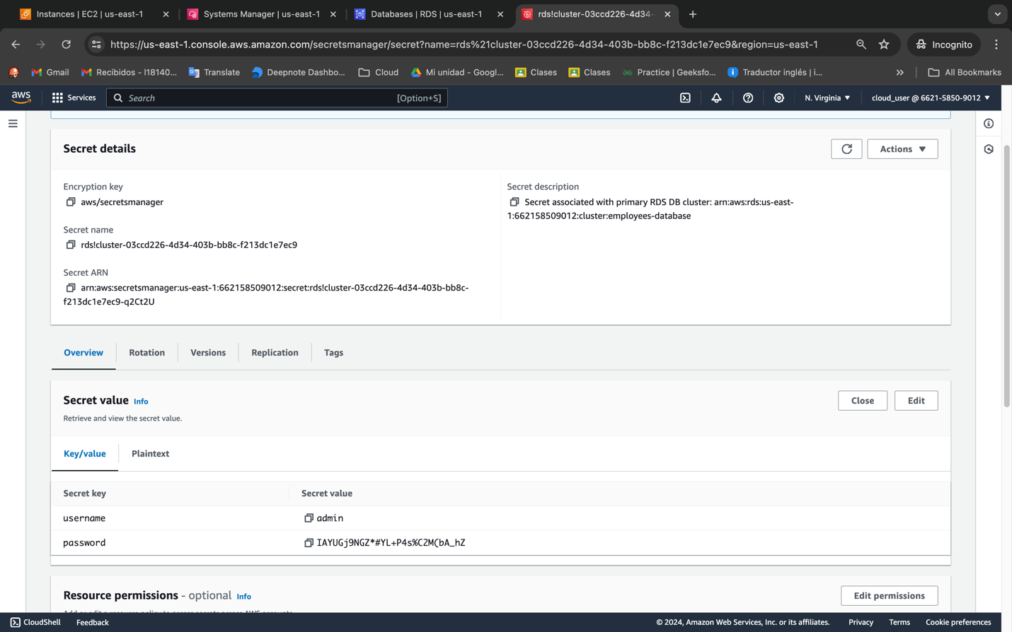

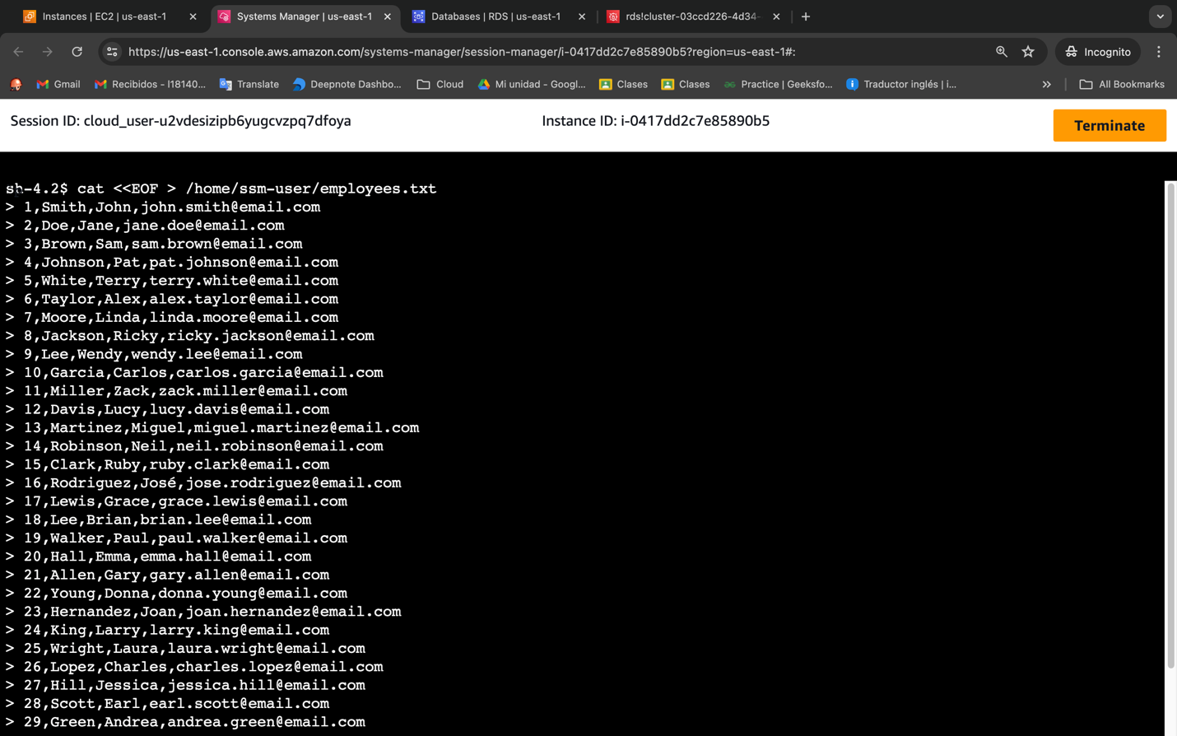

cat <<EOF > /home/ssm-user/employees.txt

1,Smith,John,john.smith@email.com

2,Doe,Jane,jane.doe@email.com

3,Brown,Sam,sam.brown@email.com

4,Johnson,Pat,pat.johnson@email.com

5,White,Terry,terry.white@email.com

6,Taylor,Alex,alex.taylor@email.com

7,Moore,Linda,linda.moore@email.com

8,Jackson,Ricky,ricky.jackson@email.com

9,Lee,Wendy,wendy.lee@email.com

10,Garcia,Carlos,carlos.garcia@email.com

11,Miller,Zack,zack.miller@email.com

12,Davis,Lucy,lucy.davis@email.com

13,Martinez,Miguel,miguel.martinez@email.com

14,Robinson,Neil,neil.robinson@email.com

15,Clark,Ruby,ruby.clark@email.com

16,Rodriguez,José,jose.rodriguez@email.com

17,Lewis,Grace,grace.lewis@email.com

18,Lee,Brian,brian.lee@email.com

19,Walker,Paul,paul.walker@email.com

20,Hall,Emma,emma.hall@email.com

21,Allen,Gary,gary.allen@email.com

22,Young,Donna,donna.young@email.com

23,Hernandez,Joan,joan.hernandez@email.com

24,King,Larry,larry.king@email.com

25,Wright,Laura,laura.wright@email.com

26,Lopez,Charles,charles.lopez@email.com

27,Hill,Jessica,jessica.hill@email.com

28,Scott,Earl,earl.scott@email.com

29,Green,Andrea,andrea.green@email.com

30,Adams,Shirley,shirley.adams@email.com

EOF

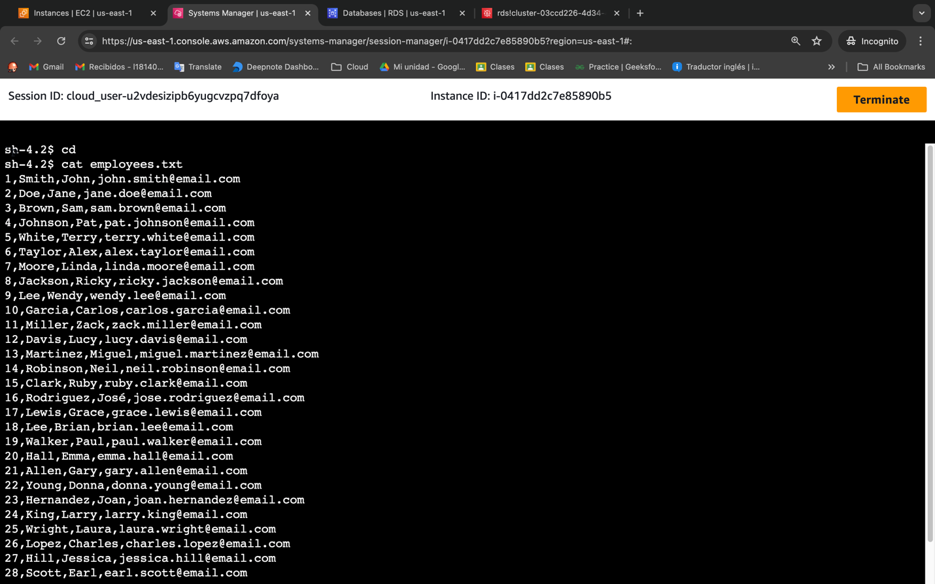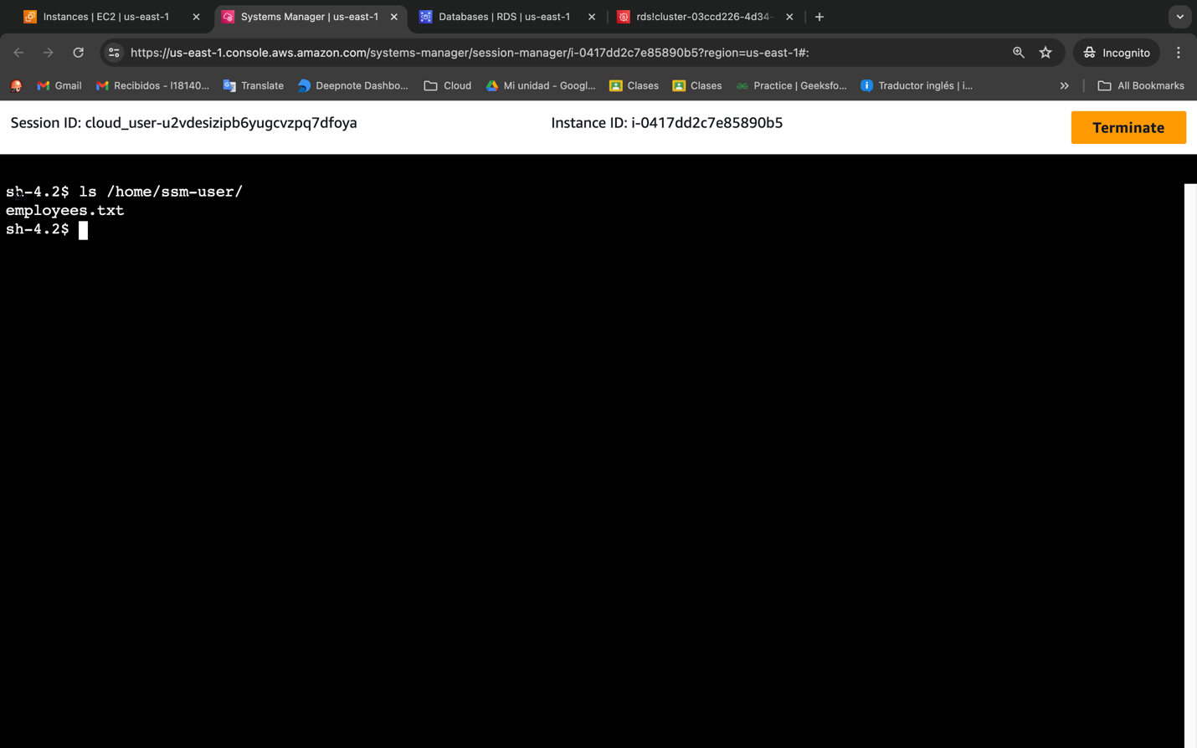

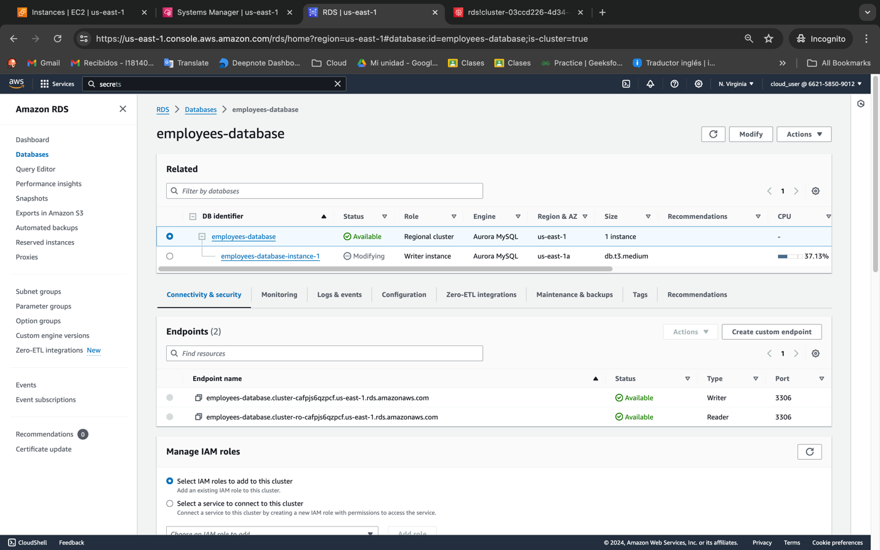

mysql --host=CHANGE_TO_WRITER_ENDPOINT_NAME --user=admin --password employees_db

employees-database.cluster-cafpjs6qzpcf.us-east-1.rds.amazonaws.com

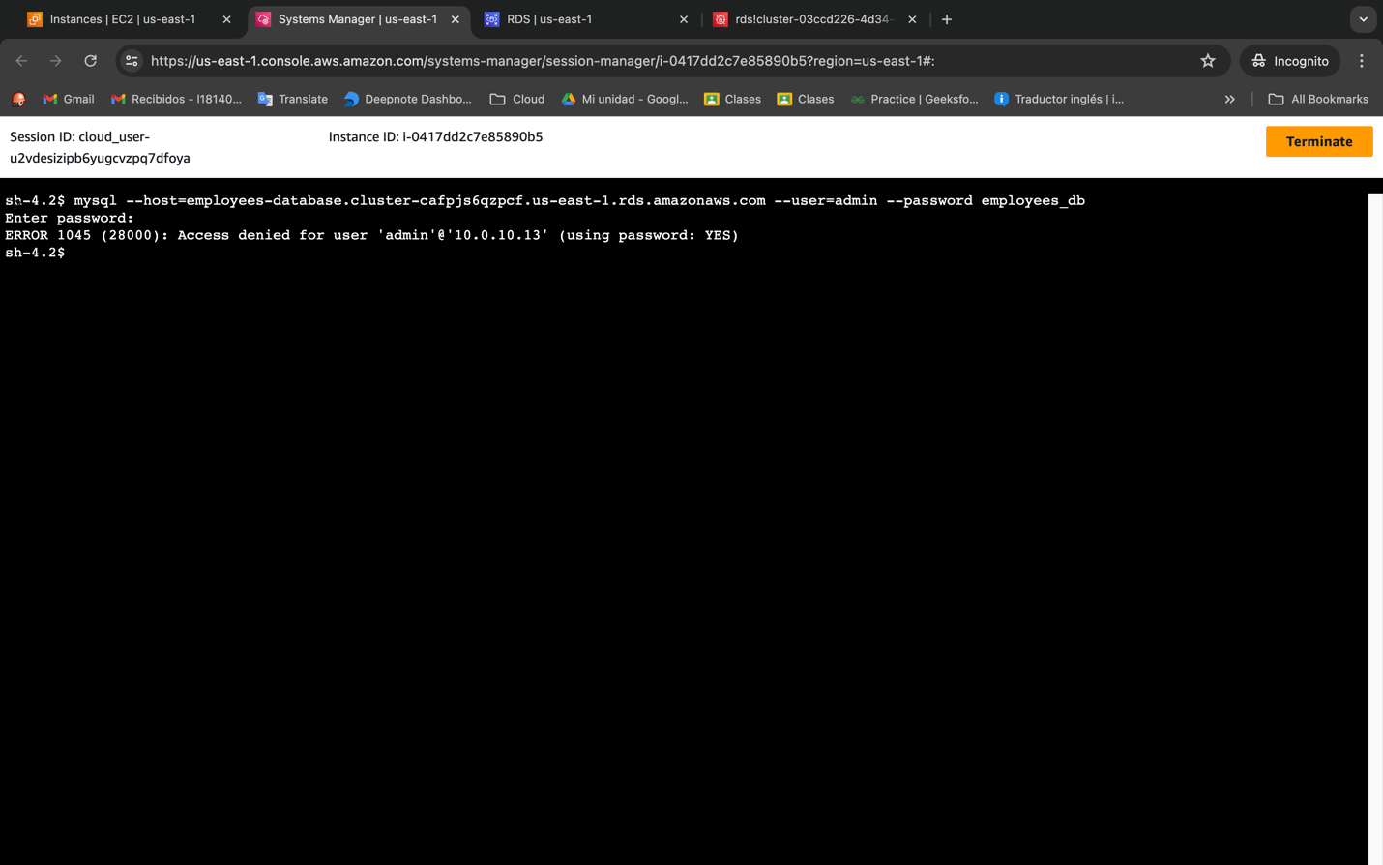

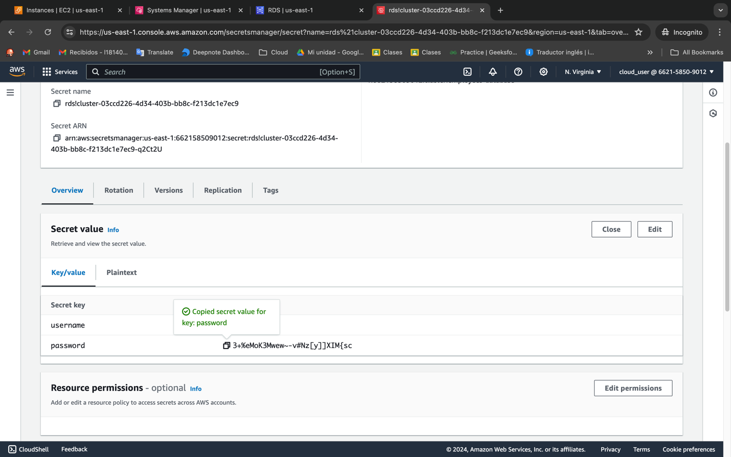

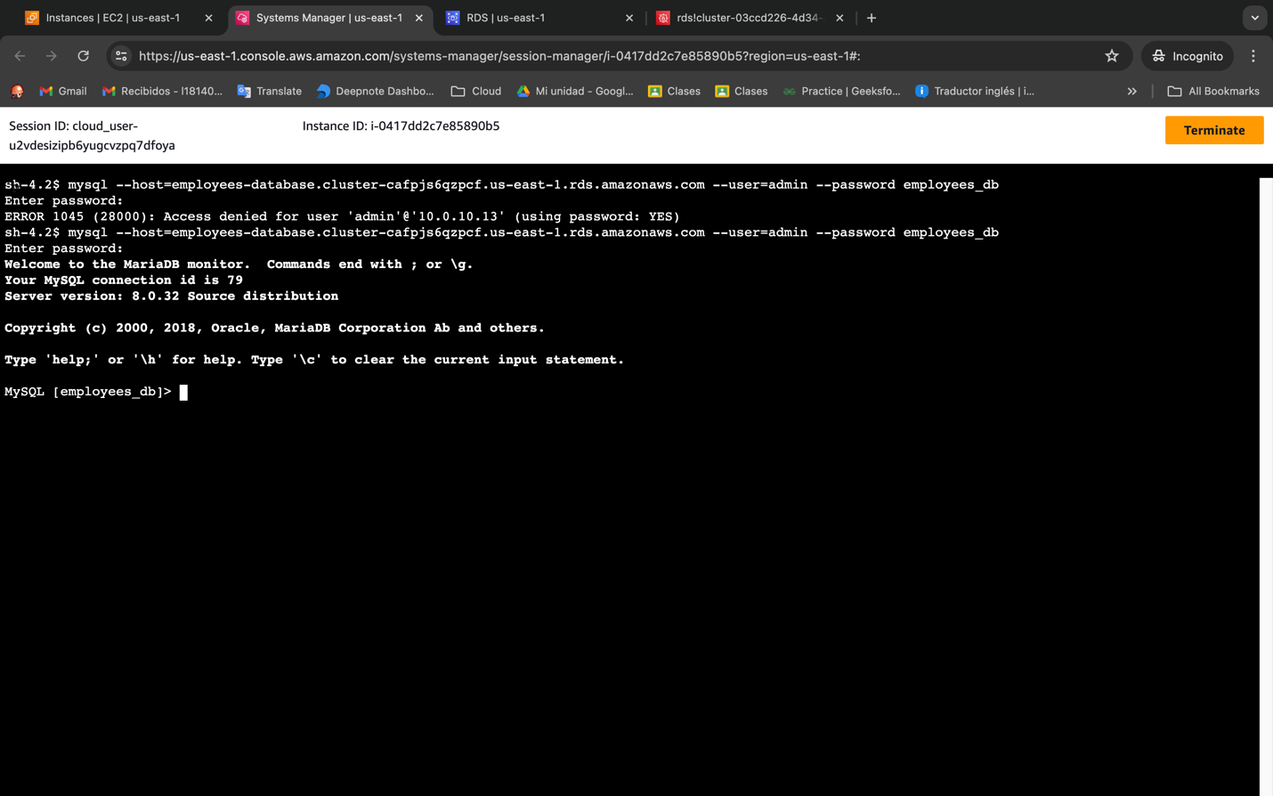

1. Now, copy and paste the password from the AWS Secrets Manager secret value into the Session Manager prompt. **Also keep this password in your clipboard or a text file, as we will use this again for testing in a moment.**

CREATE TABLE Employees ( EmployeeId int, LastName varchar(255), FirstName varchar(255), Email varchar(255) );

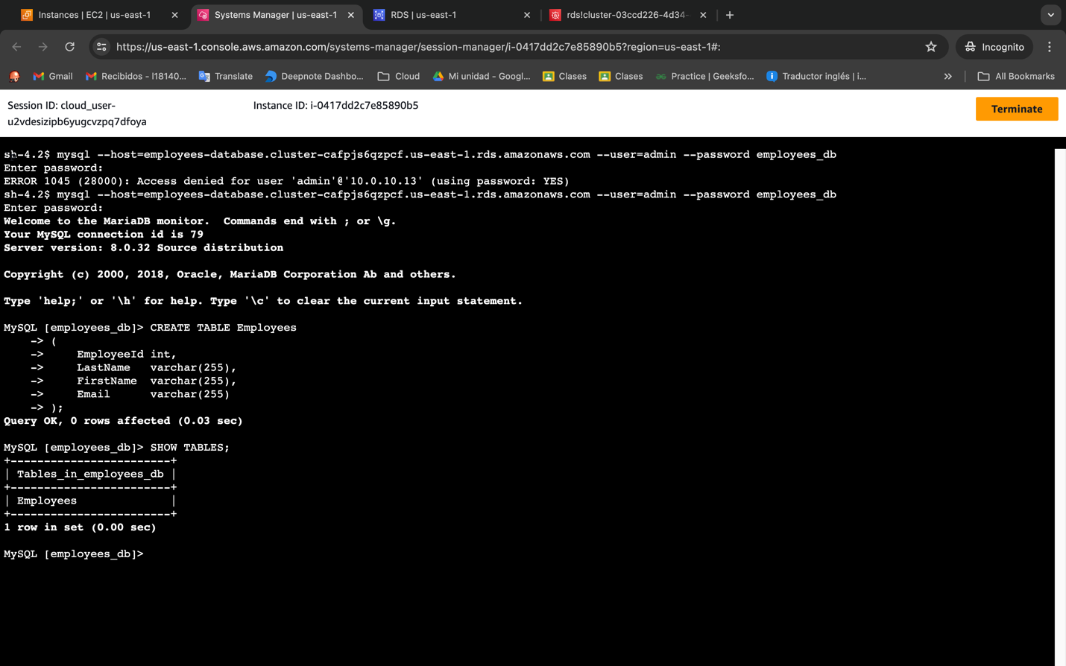

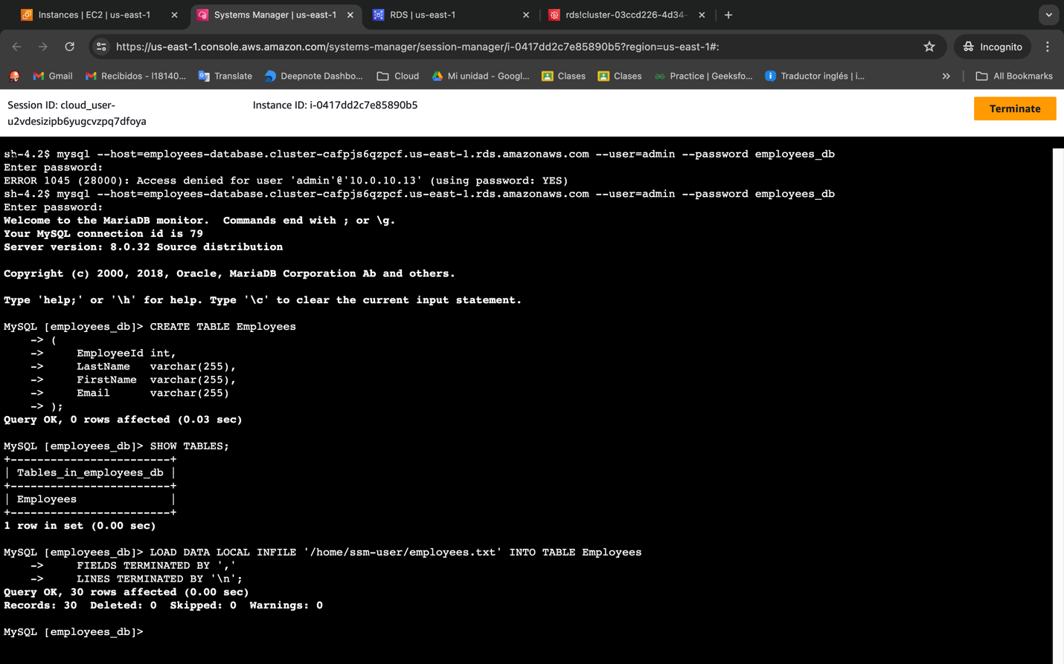

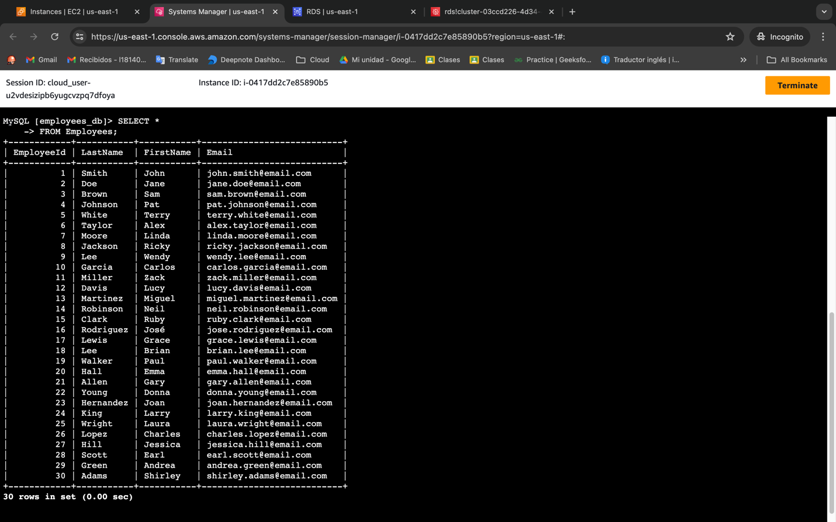

3+%eMoK3Mwew~-v#Nz[y]]XIM{sc

